Personal History Beats Personas: Calibrating LLM Shopper Judges Against Real Purchases
Sai Gowtham Reddi
Independent Researcher
448.gowtham.reddi@gmail.com
Abstract
When an online shop asks an AI model whether a search result is relevant, the model usually answers as an imaginary "typical shopper". But real shoppers differ: someone with a Samsung phone has no use for an iPhone case, however well it matches the query. We ask how an AI judge should be told who the shopper is: by describing the shopper's customer segment (a persona built from how similar people shop), by showing the judge the shopper's own purchase history, or both.
Using public Amazon data in two categories, phone accessories and video games, we ask each judge to pick out the product a real shopper actually bought from a set of similar products they passed over. Predictions were fixed before each test, and the main result was confirmed on 2023 data that had not been used before.
Segment personas capture something real: the right persona beats the wrong one by about 0.07 AUC in both categories. But a shopper's own history works better. It improves the judge by 0.090 (phones) and 0.038 (video games) AUC and beats the segment persona by 0.055 and 0.043, while adding the persona on top of history does not help. Personas only matched personal history when nearly everyone in a segment used the same platform. Price-based personas, price rules and example purchases did not help. We recommend judging each shopper by their own history and using segments only to report results.
Keywords: LLM-as-a-judge; relevance evaluation; e-commerce search; personalization; customer segmentation; user simulation; large language models; product search

1. Introduction
Large language models (LLMs) are increasingly used in place of human annotators to judge whether search results are relevant. Microsoft reported that LLM labels at Bing matched real searcher preferences better than third-party human labellers [1]; the open-source UMBRELA assessor reproduced this on TREC data [2]; and industry teams at Pinterest and Zalando use LLM judges to evaluate search at scale [6, 7]. In almost all of this work the judge evaluates results as a single generic searcher.
In e-commerce that assumption is visibly wrong. Whether a phone case is relevant depends on which phone the shopper owns; whether a controller is relevant depends on their console. A generic judge must guess. Two natural ways to tell the judge who the customer is are (i) a segment persona, a written description of a behavioural customer segment, and (ii) the individual shopper's own purchase history. Personas are attractive because they are compact, interpretable and match how businesses already think about customers; history is more specific but requires per-user data. To our knowledge, these two forms of customer context have not been compared head to head against real purchase outcomes.
We run that comparison on public Amazon data in two categories. Our contributions are:
- An evaluation protocol that tests LLM judges against held-out real purchases using choice sets, with a matched-versus-mismatched persona test, a generic-judge and popularity baseline, and separate development, test and untouched holdout windows with predictions fixed in advance.
- Evidence that behavioural personas carry real, segment-specific preference: a segment's own persona beats other segments' personas by about 0.07 AUC in both categories, and the wrong persona actively misleads.
- Evidence that individual history beats personas, confirmed on the 2023 holdout in both categories, and that adding the persona on top of history does not help.
- Negative results that save practitioners effort: price-based personas, price rules and few-shot purchase examples did not improve judges.

2. Related work
LLM relevance judges. Thomas et al. [1] showed LLM labels can match real searcher preferences when the prompt is tuned against first-party feedback. UMBRELA [2] reproduced the approach and was used in the TREC 2024 RAG Track, where LLM judgments correlated well with human judgments at the system level [3, 5]. Clarke and Dietz [4] caution that agreement drops among the top systems and that LLM judges can be gamed, so automatic judges should be validated against human or behavioural ground truth. In e-commerce, Zalando [7] and Pinterest [6] report human-comparable LLM relevance labels, and a study of a deployed e-commerce assistant found LLM judges have context-dependent blind spots [18].
LLM user simulation. USimAgent [8] and BASES [9] simulate search sessions with LLM agents; PUB [10] builds simulated users from behavioural logs for recommender evaluation. GAUGE [11] and work on verifiable user simulation [12] argue that simulator-plus-judge pipelines must be checked against grounded outcomes, which is the role our calibration protocol plays.
Persona and history conditioning. Persona conditioning has been studied as a probe of LLM assessor sensitivity, where personas are assessor roles rather than customer segments [13]. Closest to our history condition, an ads-retrieval study judges products against intents inferred from users' engagement histories [14]. We differ in comparing segment personas and individual history directly, in a query-free choice setting, against real held-out purchases in two categories.
Data. We use the Amazon Shopping Queries dataset (ESCI) [15] and Amazon Reviews 2023 [16]. Public e-commerce data with readable search queries linked to users is scarce: JDsearch [17] links real searches to users but releases queries as anonymised term IDs, which an LLM judge cannot read. We therefore use verified purchases as the behavioural signal.

3. Evaluation protocol

3.1 Choice-set task
For a shopper who bought a product in an evaluation window, we build a choice set of 10 products: the purchased product plus 9 products from the same leaf subcategory that the shopper never bought. Negatives are sampled in proportion to the square root of their sales in the same window, so sets resemble a realistic results page without being dominated by a few bestsellers. Products are shown in random order with title, brand, price, star rating, review count and up to 200 characters of feature text. Each judge returns, for every product, a probability that this shopper would choose it (p_buy).
The score for a set is the AUC of the bought item: the fraction of the 9 alternatives scored below it (ties count half). AUC is 0.5 for a random judge and 1.0 for a perfect one. We report means per segment with 95% bootstrap confidence intervals (2,000 resamples of sets) and compare judges with paired differences on the same sets.

3.2 Baselines and tests
- Generic judge: the same LLM and instructions with the persona "You are a typical online shopper."
- Popularity: each product's number of purchases in 2019–2021.
- Matched versus mismatched: each segment's purchases are also judged by every other segment's persona. If personas carry segment-specific information, the matched persona should win.
- Calibration gate: a segment's persona is considered calibrated when its AUC exceeds both the generic judge and popularity with 95% intervals above zero.

3.3 Time windows
Segments, personas and each shopper's history use only 2019–2021 purchases. Judges are evaluated on later purchases: a development window (January–June 2022), a test window (July–December 2022) and a holdout window (January–September 2023, the end of the data). Prompt changes were made only on development data; predictions were written down before each test and holdout run, and the holdout was used once.

4. Data and segments
We use the Cell Phones & Accessories category of Amazon Reviews 2023 (20.8M reviews, 19.7M verified purchases, 1.29M products) and the Video Games category (137K products). Verified purchases serve as the behavioural signal; product metadata provides title, brand, price, rating, review count and category path.
Shoppers with at least three priced purchases in 2019–2021 and at least one purchase in 2022 were clustered with k-means on standardised features: share of purchases in the cheapest and most expensive quarter of their subcategory, brand loyalty, share of purchases for each device ecosystem or gaming platform (detected from product titles), median product popularity and purchase volume. The number of clusters was chosen by silhouette score. Each segment's persona was generated from its statistics by fixed rules (typical prices paid, ecosystem shares, frequent brands and subcategories, and a few judging cues), reviewed once, and then frozen. Table 1 summarises the segments.
Table 1. Behavioural segments. Homogeneity is the share of a segment's purchases made for its main ecosystem or platform.
Category | Segment | Shoppers | Share | Homogeneity
Phones | Apple premium mainstream | 30,094 | 33% | 0.84 (Apple)
Phones | Samsung loyalists | 24,916 | 27% | 0.73 (Samsung)
Phones | Frequent multi-device buyers | 18,442 | 20% | 0.50 (Apple)
Phones | Budget hunters | 18,244 | 20% | 0.45 (Apple)
Video games | Nintendo loyalists | 2,012 | 23% | 0.76 (Nintendo)
Video games | PC gaming gear enthusiasts | 1,581 | 18% | 0.72 (PC)
Video games | PlayStation players | 1,438 | 16% | 0.70 (PlayStation)
Video games | Frequent multi-platform buyers | 1,296 | 15% | 0.42 (Nintendo)
Video games | Budget Nintendo buyers | 1,206 | 14% | 0.53 (Nintendo)
Video games | Xbox players | 1,195 | 14% | 0.71 (Xbox)

5. Judges
All judges use the same model, instructions and output format; only the customer context changes:
- Generic: "You are a typical online shopper."
- Segment persona: the shopper's segment profile (about 150 words).
- Persona + examples: the persona plus three past choices by segment members in the same subcategory (bought item marked among four passed-over items), selected at random or matched to the current set's ecosystem and price range.
- Generic + history: the generic persona plus the shopper's own 2019–2021 history: the share of purchases per ecosystem or platform and their five most recent purchases (title, subcategory, price).
- Persona + history: the segment persona plus the same history.
We compared a local model (qwen3:8b via Ollama) with gpt-4.1-mini on ESCI-labelled search results, including a noise test that re-judges the same products in a different order (Table 2). The local model changed its grade on 47% of products when only the order changed, which is larger than the segment effects we aim to measure, so all reported experiments use gpt-4.1-mini at temperature 0 with schema-constrained JSON output. In total the study made about 27,000 judge calls.
Table 2. Judge reliability on ESCI search results (generic judge).
Measure | qwen3:8b (local) | gpt-4.1-mini
Agreement with ESCI human labels (weighted kappa) | 0.25 | 0.39
Self-agreement after reordering products (kappa) | 0.49 | 0.88
Grade changes by at least 1 after reordering | 47% | 19%
Seconds per call | 13 | 2
The qwen3:8b figures come from 8 queries (96 products) and the gpt-4.1-mini figures from 24 queries (288 products).

6. Results

6.1 Personas carry segment-specific preference
Figure 1 shows each segment's test-window purchases judged by every persona. The diagonal (a segment's own persona) is consistently strong, and mismatched personas can fall below random: the Samsung persona scores 0.46 on Apple buyers' purchases and the Nintendo persona 0.47 on PlayStation players'. Averaged over segments, the matched persona beats mismatched personas by +0.068 (95% CI +0.047 to +0.088) for phones and +0.066 (+0.051 to +0.083) for video games. Personas built from behaviour therefore encode real, segment-specific preference, mostly about which ecosystem a shopper buys for.
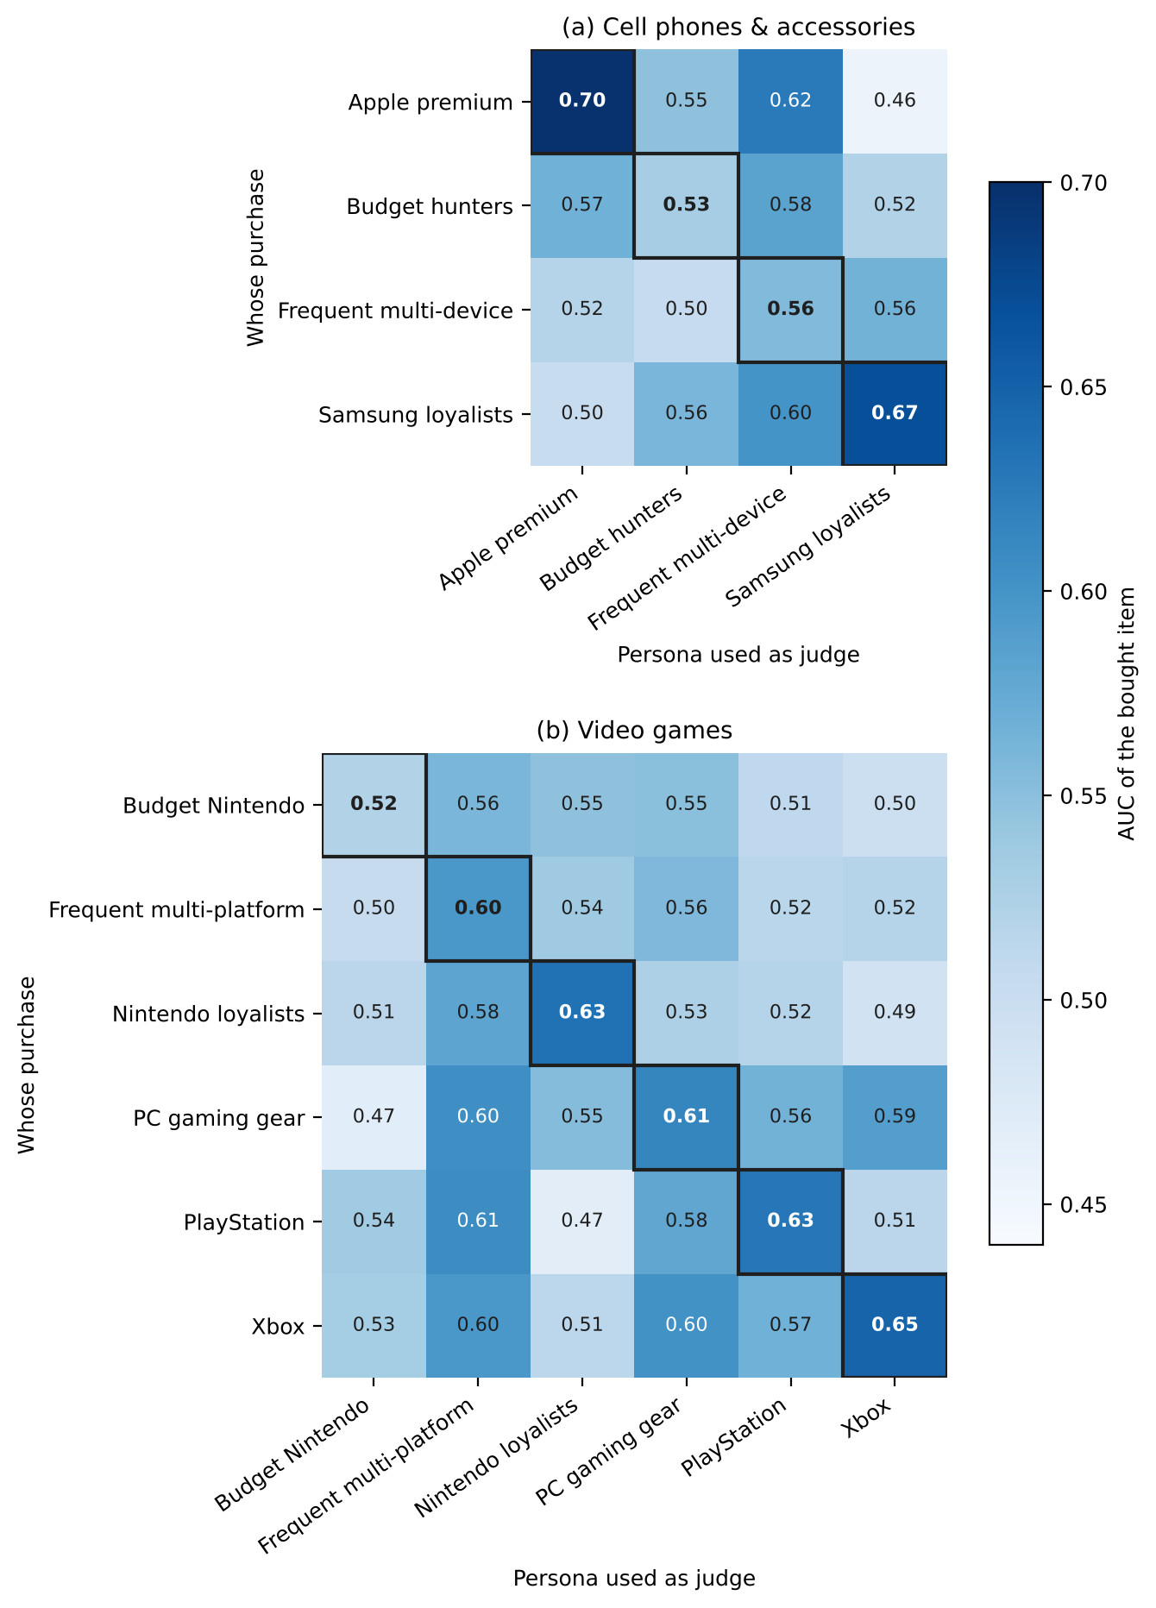
Figure 1. AUC of the bought item, test window. Rows: whose purchase; columns: which persona judged. Outlined cells are matched personas.
Gains over the generic judge were smaller and uneven (Table 3). For phones, Samsung loyalists gained +0.127 (+0.076 to +0.177) and passed the calibration gate, while the generic judge scored only 0.542 on their purchases against 0.665 on Apple buyers', suggesting the generic judge implicitly assumes the majority customer. This majority effect did not replicate in video games, where no segment's persona beat the generic judge with an interval above zero. Pooled over segments, matched personas beat the generic judge by only +0.018 (phones) and +0.010 (video games), neither significant.
Table 3. Segment personas in the test window (200 sets per segment). Differences are paired, with 95% CIs.
Segment | Own persona | Generic | Popularity | Own − generic | Own − mismatched
Phones: Samsung loyalists | 0.669 | 0.542 | 0.569 | +0.127 (+0.076, +0.177) | +0.116 (+0.069, +0.162)
Phones: Apple premium | 0.697 | 0.665 | 0.639 | +0.032 (−0.001, +0.063) | +0.155 (+0.119, +0.190)
Phones: Frequent multi-device | 0.555 | 0.560 | 0.532 | −0.005 (−0.044, +0.033) | +0.026 (−0.008, +0.058)
Phones: Budget hunters | 0.531 | 0.615 | 0.549 | −0.084 (−0.130, −0.036) | −0.025 (−0.068, +0.016)
Games: Xbox | 0.648 | 0.612 | 0.615 | +0.036 (−0.012, +0.084) | +0.086 (+0.045, +0.126)
Games: Nintendo loyalists | 0.634 | 0.604 | 0.552 | +0.029 (−0.014, +0.075) | +0.108 (+0.067, +0.148)
Games: PlayStation | 0.628 | 0.588 | 0.584 | +0.040 (−0.003, +0.085) | +0.087 (+0.047, +0.127)
Games: PC gaming gear | 0.614 | 0.627 | 0.570 | −0.013 (−0.051, +0.028) | +0.059 (+0.025, +0.091)
Games: Frequent multi-platform | 0.596 | 0.602 | 0.519 | −0.006 (−0.038, +0.025) | +0.070 (+0.040, +0.100)
Games: Budget Nintendo | 0.521 | 0.549 | 0.543 | −0.028 (−0.077, +0.021) | −0.012 (−0.053, +0.030)

6.2 What did not work
Price personas and price rules. Budget segments were the weakest in both categories. Diagnosis on development data showed why: Budget hunters bought the cheapest item in a set only 4% of the time, and the bought item sat mid-range at 1.14 times the set's median price. A price-focused persona cue misled the judge, and a revised cue ("avoid clearly overpriced items, then choose well-reviewed products") changed AUC only from 0.552 to 0.567. Simple rules confirm the pattern (Table 4): "cheapest first" scored below random in both categories (0.482 and 0.449), and closeness to the shopper's usual price position was at chance level.
Few-shot examples. Showing each persona three past choices by its segment did not help on development data. The matched persona's lead over the generic judge stayed near +0.03 (none: +0.032; random examples: +0.033; similar examples: +0.029), and its lead over mismatched personas shrank from +0.093 to about +0.07.
Table 4. Simple rules from each shopper's own 2019–2021 history versus LLM judges, test window, AUC averaged over all sets.
Method | Phones | Video games
Cheapest first | 0.482 | 0.449
Price fit to own usual price position | 0.501 | 0.521
Brand match to own history | 0.531 | 0.543
Popularity (2019–2021 sales) | 0.572 | 0.564
Ecosystem match to own history | 0.642 | 0.581
Combined rule (ecosystem + price fit + popularity) | 0.620 | 0.593
LLM generic judge | 0.595 | 0.597
LLM segment persona | 0.613 | 0.607
LLM segment persona + combined rule | 0.634 | 0.616
Table 4 also previews the main result: a rule that only checks whether a product fits the devices the shopper has bought for already rivals the LLM persona for phones (0.642 versus 0.613). Device compatibility, which an individual's history reveals directly, is the dominant signal.

6.3 Main result: own history versus personas (holdout)
Based on development results, we fixed three predictions before running the 2023 holdout: (H1) adding the shopper's own history improves the generic judge; (H2) generic + history beats the segment persona; (H3) adding the persona on top of history gives no further gain. All three held in both categories (Table 5).
Table 5. Holdout results (January–September 2023). AUC averaged over sets; differences paired, with 95% CIs.
 | Phones | Video games
Generic | 0.586 | 0.594
Segment persona | 0.621 | 0.589
Generic + own history | 0.675 | 0.632
Segment persona + own history | 0.665 | 0.609
H1: (generic + history) − generic | +0.090 (+0.068, +0.111) | +0.038 (+0.021, +0.055)
H2: (generic + history) − persona | +0.055 (+0.034, +0.074) | +0.043 (+0.027, +0.061)
H3: (persona + history) − (generic + history) | −0.011 (−0.027, +0.006) | −0.024 (−0.038, −0.009)
History improved the generic judge in every phone segment, by +0.044 to +0.130. The persona added nothing once history was present and significantly hurt in video games, most for PlayStation players (−0.049), plausibly because a cue such as "items for other platforms are irrelevant" overrides a history showing purchases across platforms. Gains were smaller in video games, consistent with game choices depending more on content than on device compatibility.
Figure 2 shows where personas lose. In phones, the persona matched individual history for the two homogeneous segments (Apple +0.014, Samsung −0.006, neither significant) and lost clearly for mixed segments (Frequent multi-device +0.121, Budget hunters +0.090). In video games, history beat the persona in most segments regardless of homogeneity, the PC segment being the exception. Homogeneity therefore appears necessary but not sufficient for a persona to stand in for individual knowledge.
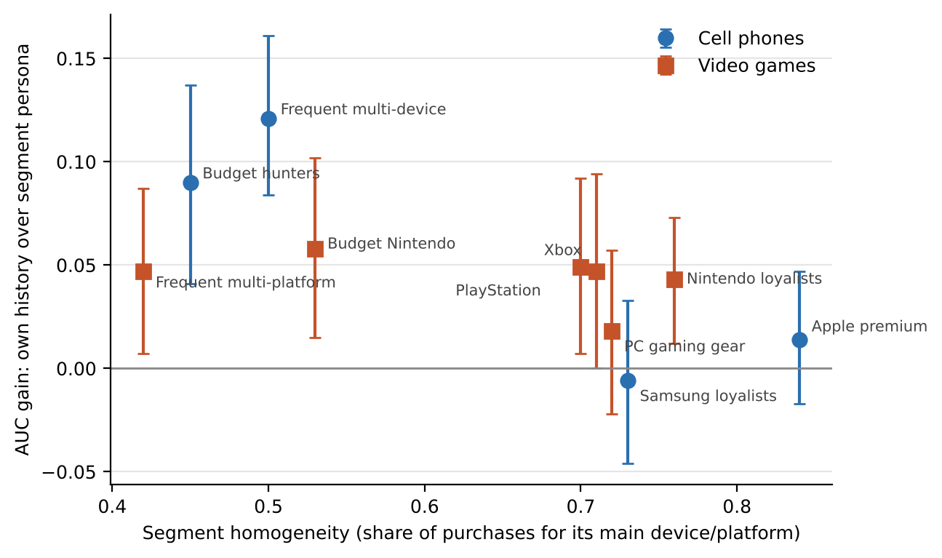
Figure 2. Holdout gain of the generic judge with own history over the segment persona, by segment homogeneity. Bars are 95% bootstrap intervals.

7. Discussion
A segment persona is best understood as a compressed guess about an individual. When a segment is homogeneous, for example nearly everyone owns an iPhone, the guess is right and the persona performs about as well as the individual's own history. When a segment mixes customers, the persona is wrong for many of its members, and only individual history tells the judge which device a given shopper owns. Price, the most intuitive basis for segmentation, carried little signal: within a category shoppers choose well-reviewed products that fit their device, not the cheapest option.
For practitioners this suggests a simple design for customer-aware relevance evaluation: judge each sampled shopper with their own history, and use segments only as reporting units, averaging per-shopper judgments by segment to produce segment scorecards. This keeps the business-friendly segment view while using the most accurate judge, and it avoids personas imposing stereotypes on individuals who do not fit them. Where only segment information is available, personas still improve on a generic judge for segments whose behaviour diverges from the majority, as Samsung loyalists did for phones.
The whole study cost little to run. At about 2 seconds per call and about 27,000 calls with a small commercial model, a full calibration of this kind is affordable for most teams, which makes testing a judge against real behaviour before trusting it a practical habit rather than a luxury.

8. Limitations and ethics
- Metadata snapshot. Product titles and review counts come from a 2023 crawl; some listings were renamed after purchase, and review counts partly accumulated after the purchases being predicted. All judges see the same information, so comparisons between judges remain fair, but absolute AUCs may be inflated.
- Purchases, not search. We evaluate choices among comparable products rather than ranked search results, and verified reviews stand in for purchases. Search-history conditioning remains untested because public data with readable, user-linked queries is unavailable.
- One judge model and two categories from one retailer's public data. Results may differ for other models, categories or markets; some video-game segments had fewer than 200 holdout shoppers.
- Ethics. The study used only public datasets with anonymised user identifiers; no participants were recruited and no attempt was made to re-identify individuals. Personas risk stereotyping customers; our results suggest individual history is both more accurate and less prone to this.

9. Conclusion and future work
Telling an LLM judge who the customer is matters, and how it is told matters more. Behaviour-based personas capture genuine segment preferences, but a shopper's own purchase history is the stronger signal in both categories we tested, and the persona adds nothing once history is known. Future work should test search-history conditioning with real or study-collected logs, repeat the comparison with other judge models, and measure whether history-conditioned judges change which retrieval systems look best for each customer segment.
Data and code availability. All data are public: the Amazon Shopping Queries dataset [15] and Amazon Reviews 2023 [16]. Scripts that reproduce every table and figure will be released with the camera-ready version.

References
[1] P. Thomas, S. Spielman, N. Craswell, B. Mitra. Large language models can accurately predict searcher preferences. arXiv:2309.10621, 2023.
[2] S. Upadhyay, R. Pradeep, N. Thakur, N. Craswell, J. Lin. UMBRELA: UMbrela is the (open-source reproduction of the) Bing RELevance Assessor. arXiv:2406.06519, 2024.
[3] S. Upadhyay, R. Pradeep, N. Thakur, D. Campos, N. Craswell, I. Soboroff, H. T. Dang, J. Lin. A large-scale study of relevance assessments with large language models: an initial look. arXiv:2411.08275, 2024.
[4] C. L. A. Clarke, L. Dietz. LLM-based relevance assessment still can't replace human relevance assessment. EVIA 2025; arXiv:2412.17156.
[5] N. Thakur, R. Pradeep, S. Upadhyay, D. Campos, N. Craswell, J. Lin. Assessing support for the TREC 2024 RAG Track: a large-scale comparative study of LLM and human evaluations. SIGIR 2025.
[6] H. Wang, A. Whitworth, P. M. Cheung, Z. Zhang. LLM-based relevance assessment for web-scale search evaluation at Pinterest. arXiv:2509.03764, 2025.
[7] Retrieve, annotate, evaluate, repeat: leveraging multimodal LLMs for large-scale product retrieval evaluation (Zalando). arXiv:2409.11860, 2024.
[8] USimAgent: large language models for simulating search users. arXiv:2403.09142, 2024.
[9] R. Ren et al. BASES: large-scale web search user simulation with large language model based agents. arXiv:2402.17505, 2024.
[10] PUB: an LLM-enhanced personality-driven user behaviour simulator for recommender system evaluation. arXiv:2506.04551, 2025.
[11] GAUGE: when not to trust LLM-as-a-judge in user-simulated evaluation of task-oriented agents. arXiv:2609.12191, 2026.
[12] Verifiable user simulation for search and recommendation systems. arXiv:2606.14474, 2026.
[13] Persona conditioning as an assessor-sensitivity probe for LLM-based IR evaluation. arXiv:2608.10385, 2026.
[14] LLM-based user-product relevance evaluation for dynamic product advertising. arXiv:2610.14550, 2026.
[15] C. K. Reddy et al. Shopping Queries Dataset: a large-scale ESCI benchmark for improving product search. arXiv:2206.06588, 2022.
[16] Y. Hou, J. Li, Z. He, A. Yan, X. Chen, J. McAuley. Bridging language and items for retrieval and recommendation. arXiv:2403.03952, 2024.
[17] J. Liu, Z. Dou, G. Tang, S. Xu. JDsearch: a personalized product search dataset with real queries and full interactions. SIGIR 2023.
[18] A. Türkmen, K. E. Keleş. LLM-as-a-judge in e-commerce RAG systems. 2026 (ACL Anthology, 2026.mme-main.12).

Appendix A. Judge instructions
All choice-set judges received the following instruction after their persona (the history variant adds that the shopper's own purchase history is the best evidence of which devices they own):
You are shown products from one shopping category. For each product, give p_buy: the probability (0 to 1) that you, as this shopper, would choose to buy it rather than the others shown. Consider whether it fits your devices, its price compared with what you usually pay, and your brand and quality preferences. Judge each product on its own merits; ignore the order in which products are listed. Return one entry per product, using its number as "i".
Output was constrained to the JSON schema {"judgments": [{"i": integer, "p_buy": number}]}. An example persona (Samsung loyalists, phones) reads in part: "Devices: 15% of what you buy is for Apple devices and 73% for Samsung … Assume you own Samsung devices unless the query names another brand or device model; accessories for other phones are irrelevant."

